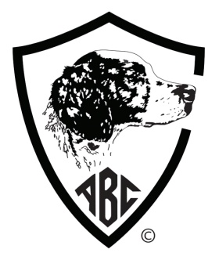 | Final Forfeit for the 2016/2018  The American Brittany Club, Inc.  70th Field Futurity ~ 55th Show Futurity  ENTRIES CLOSE OCTOBER 1, 2017  Open to all Brittanys from enrolled litters. Dogs must be owned by ABC members or members of their immediate family.
CHECK your choices of one or more sections below and enclose one check to cover total fees
SECTION |  | EASTERN | CENTRAL | WESTERN
Field Forfeit ($30.00 per section)
Show Forfeit ($30.00 per section)

Full Name of Dog: |  |  | AKC DNA (optional)
AKC # OTHER | FDSB # | Date of Birth: | Sex: |  | Color:
Name of Breeder (s):

Sire:

Dam:

Owner (s):
Address:
City: |  | State: | Zip:
Email Address: |  |  |  | Telephone:
ABC Club: |  |  | Exp:
I (we) certify and represent that the information contained in this Futurity Forfeit is true and correct to the best of my (our) knowledge. I (we) agree to comply with the ABC Futurity rules and regulations and I (we) are in good standing with the ABC.
Signature of owner:
Winnings, if any, will be paid ONLY to the Primary Owner of record as shown on the final entry form for each event

mail check with entry to
Linda Langford, ABC Futurity Secretary
PO BOX 1944
Pelham, AL 35124-5944
205-790-2133 ~ e-mail: lalangford@hotmail.com

Make checks payable to : AMERICAN BRITTANY CLUB

FOR OFFICE USE ONLY Date Received:____________________ Fee Received:______________ Check No:___________

